CT4034 - Web Development

Assignment 001
Web Site for Gloucestershire Constabulary to reduce bicycle theft

University of Gloucestershire
Contents
Website URL 3
Plesk Login Details and Accounts 3
A Table of Functional and Non-Functional Pages 3
Evidence of Understood Web Technologies 4
Testing 12
Security 16
Project Plan 17
Reference List. 19
Appendix 1: Screenshot of All Implemented Web Pages 20
Appendix 2: All Source code 28

Website URL

http://s4512742-ctxxxx.uogs.co.uk/

Plesk Login Details and Accounts

Login Details for Plesk account
Username: temp@s4512742-ctxxxx.uogs.co.uk
Password: 7HMJ#j@Ev!4zpe2EgJb&

Website link: https://s4512742-ctxxxx.uogs.co.uk/
Dummy accounts
- Public
Username: admin@public.uk
Password: admin
- Police
Username: admin@police.uk
Password: admin
- Admin
Username: admin@admin.uk
Password: admin

A Table of Functional and Non-Functional Pages

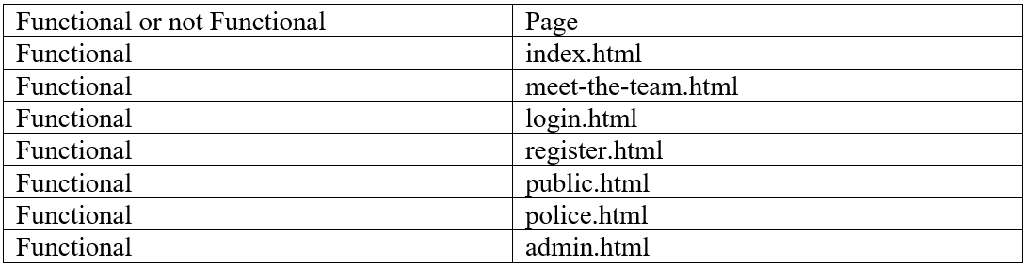
Figure 1

Evidence of Understood Web Technologies

This section will go through every page on the website to show an understanding of the languages HTML, CSS, JavaScript, PHP, MySQL and a Google map API. This will be done by using examples and snippets of code from the website.

This website uses the Database layout shown in the figure below
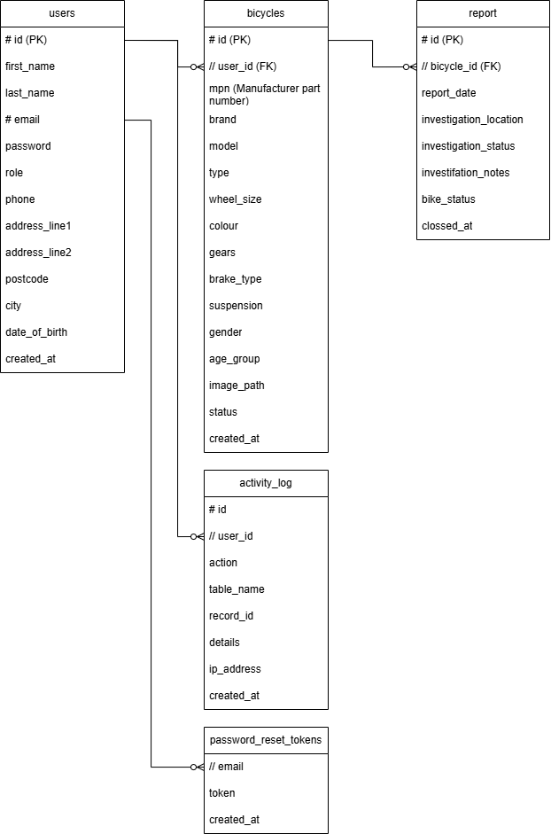
Figure 10
There are 5 tables which are connected:
- Users – contain the users names, contact information, password, rights within the system, and home address.
- Bicycles – contains all relevant information that could be used during an investigation and a photo to help identify the bike. The status states if the bike has been stolen.
- Report – contains the reports of bikes being stolen. Starting with the date of report, last location of the bike, status of the investigation and investigation notes. The date the investigation ends and cannot be reopened.
- Activity Log – contains a log of every interaction the user makes with the database. The table that was contacted, the type of alteration, the details of the report and the date and time of incident.
- Password Reset Tokens – contains the details of the CSRF token which allows the user to stay logged in for an hour.

The website opens on index.html. This page describes the initial steps to login to the system.
The index.html code starts by importing bootstraps MIT (2026) - a tool built to make resizing website faster and easier by writing the identifiers within the html code. An example of one of the identifiers is in line 24 which tells bootstrap the distance from the bottom of the navigation bar to the top of the next item.
The navigation bar is used for all pages that do not require a login. It contains the links to the other pages and is styled with the /common/sidebar.css file.
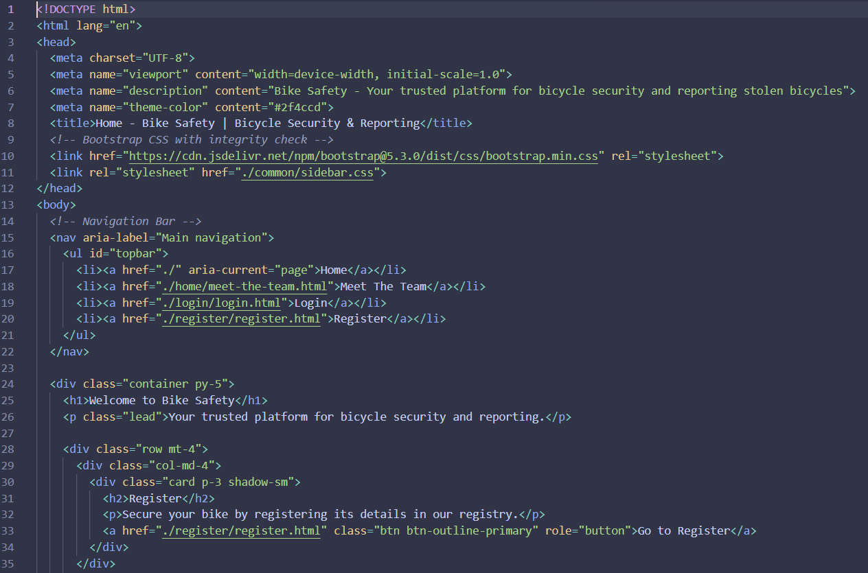
Figure 2
To allow the MIT (2026) to work properly, importing the JavaScript is required.
Figure 3

The next page found along the Navigation bar is home/meet-the-team.html. This page shows the user all the members of the team working on the project.
The file home/meet-the-team.css formats the page to make the images appear in the format of a star. On line 32 .photo points to a class within home/meet-the-team.html and tells the photo to remain in the centre above each piece of text. The function on line 39 states the size of images and creates a circular border around the outside of the image. The function on line 50 is triggered when the width of the page reaches 768 pixels and ensures the star format does not expand too far.
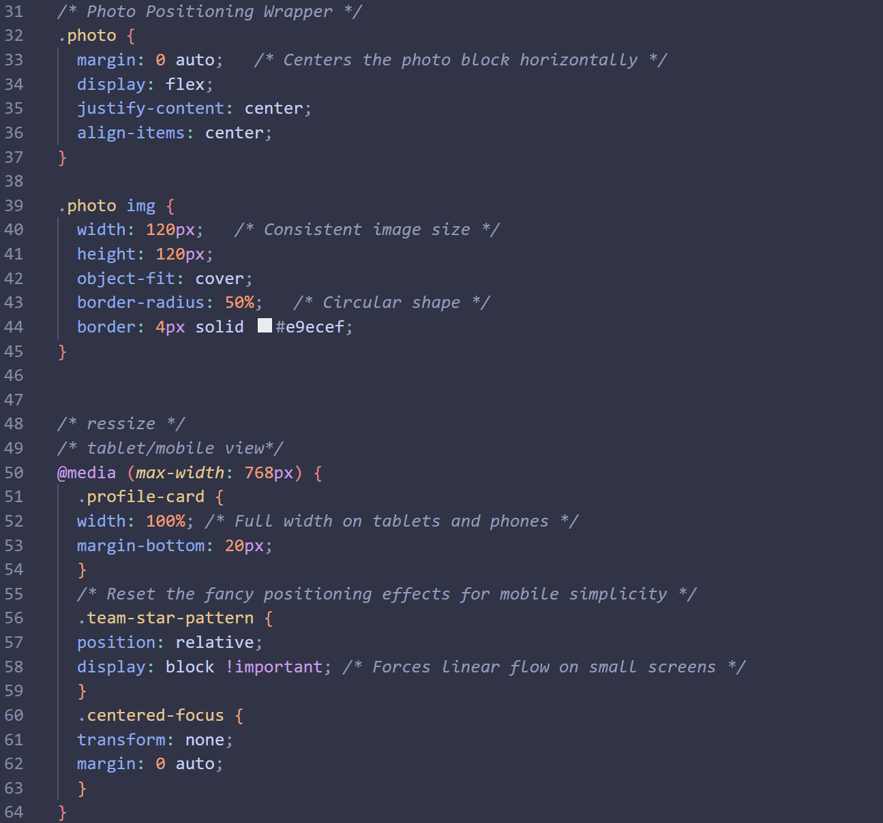
Figure 4

The login/login.html allows Public, Police and Admin users to login to the system.
All user login and registration of public users is handled by api/auth.php. The code below describes how a user is authenticated. The program starts by inputting the user login details, then sanitizing the input email to prevent SQL injection. Subsequently performing a rate limit check followed by a check to ensure that both items are filled in. The try catch statement contains a SQL query to the “users” table with the input email. If the password matches the hashed stored password, then a session is created with a token that allows it to be accessed. All required user information is stored in the session. After a session is created, a function in common/common.php is called which logs the user logging in. The user will then be redirected to the relevant page for their role. The following lines after this code are for error handling and for user responses.
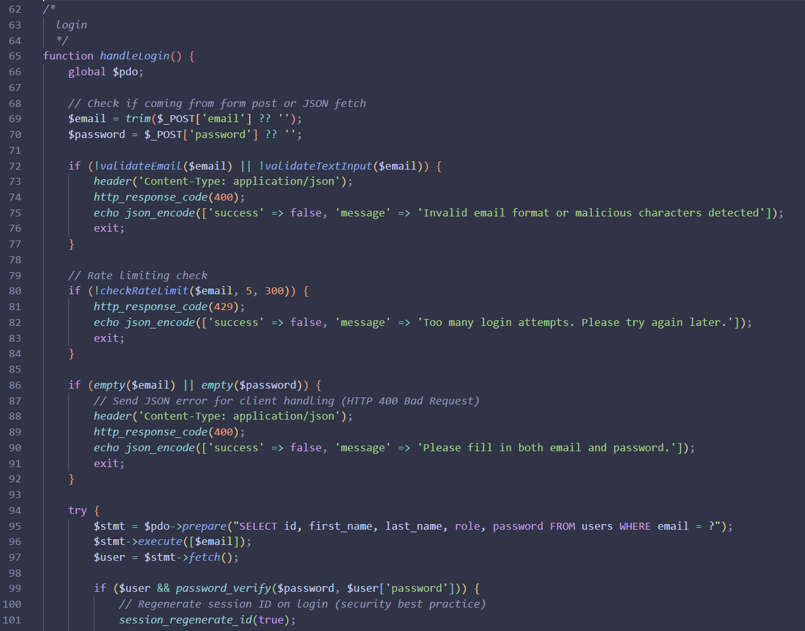
Figure 5
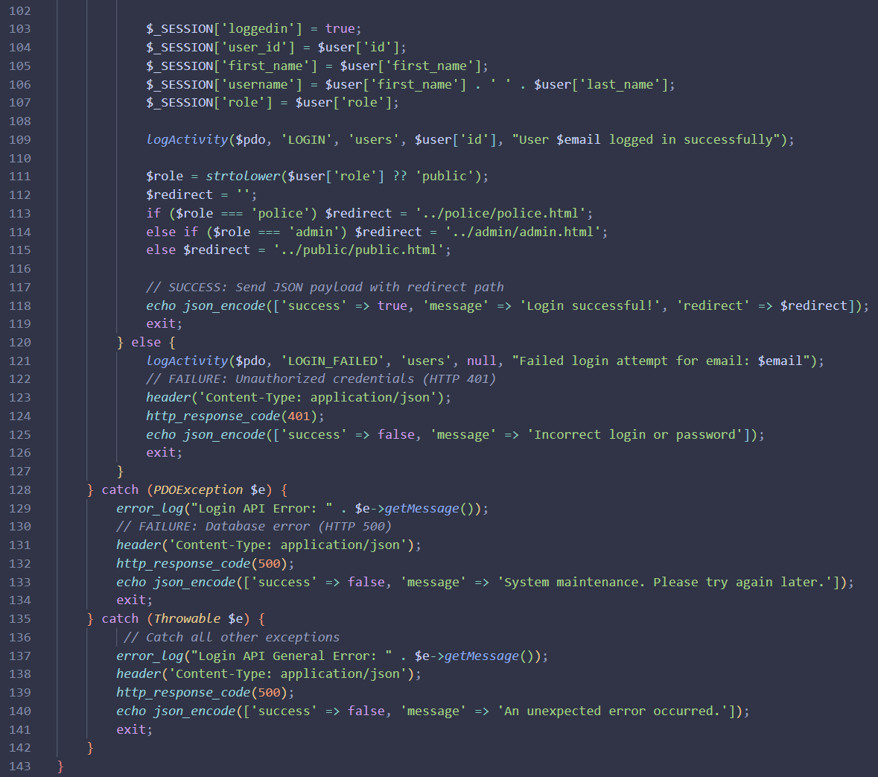
Figure 6

The final page that is accessible to everyone is register/register.html. This page allows anyone to create a Public account.
The JavaScript file register/register.js controls the information being sent to the server. This starts by gathering all input information which has been entered through the text boxes on the page, then ensures all necessary entries have been filled. Lines 124-142 sanitise the text inputs using regex statements to prevent SQL injection. The final section handles sending the input information to the server through the api/auth.php file. On a successful login, a message is displayed otherwise an error message is displayed.
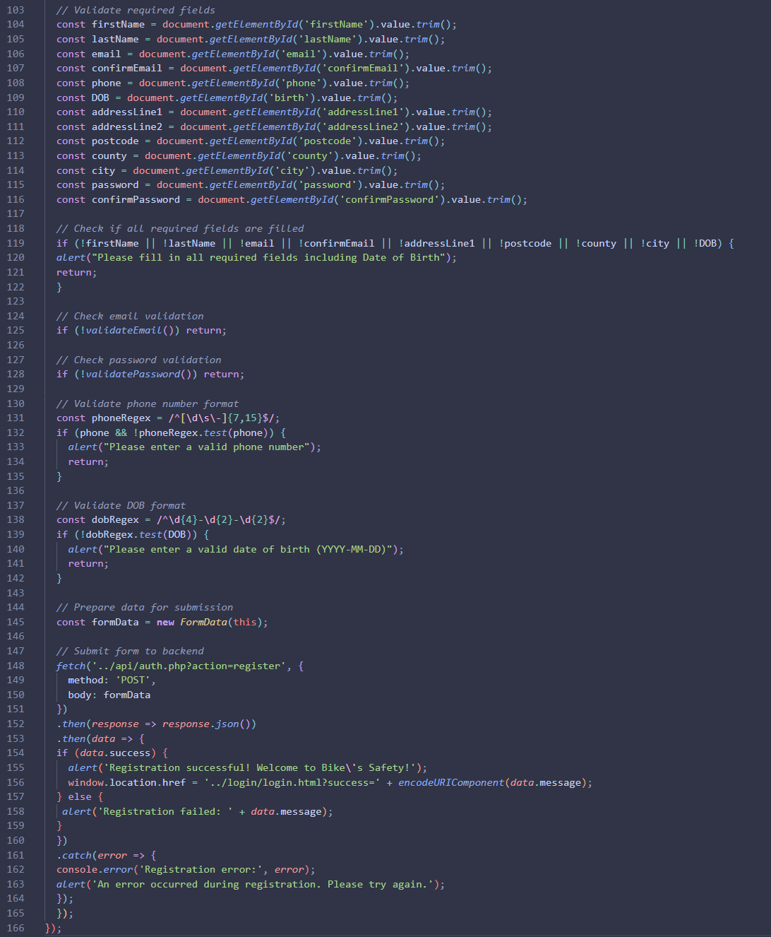
Figure 7

The Public user page is public.public.html. The page is accessible by Public and Admin users.
The features of this web page allow the Public and Admin users to:
- edit their user data
- register one or more bicycles and can report registered bicycles as stolen with a location linked using Nominatim developer community (2026)
- check the status of a stolen bike case and can report the bike as recovered if it is found independently
The function below is from common/leaflet-utils.js and calls the Nominatim developer community (2026) API so it can generate and display a map of the area entered in the location text box displayed. This function starts by checking for errors and then checks if the map exists. If the map exists, it sets the zoom length to what it was originally if a point has been located and then enables the ability to drag to place the location at a new position before exiting. If a location has not been selected the map will be set to the original scale. The Nominatim developer community (2026) API will be called to store the map on the user’s computer and create a marker of the location. The new created map is then displayed to the user.
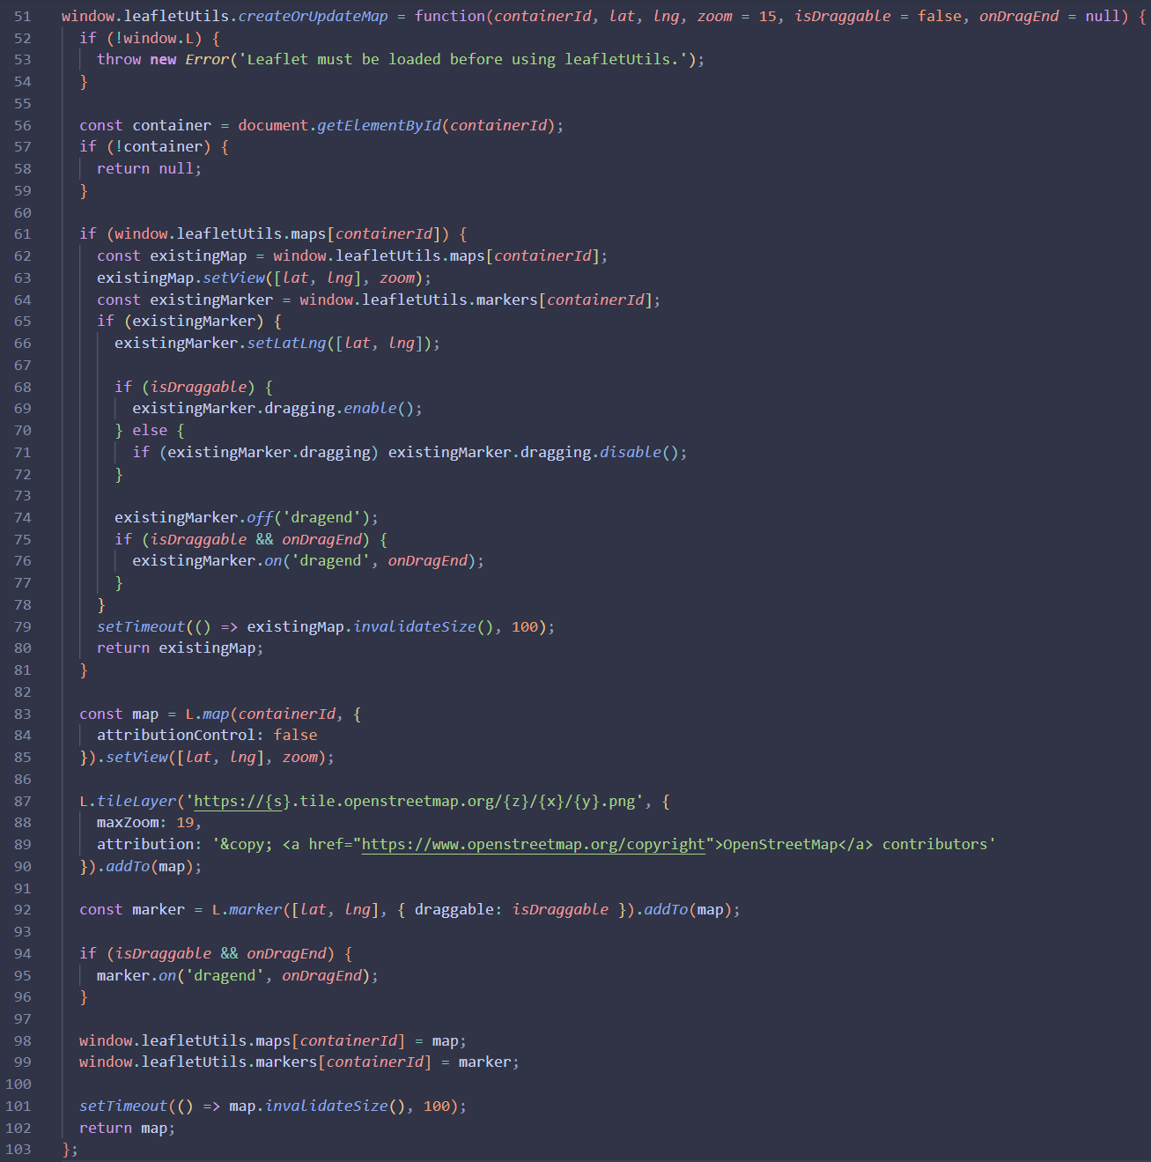
Figure 8

The Police user page is police/police.html. The page is accessible by Police and Admin users.
The features of this web page allow the Police and Admin users to:
- view a list of stolen bicycles reported by time period.
- update investigation status of reported bicycles
- update the investigation notes section tied to each separate bicycle.
The function below is from police/police.js, the function is called when a Police clicks on a bicycle they would like to view. The function first finds the bicycle details then modifies the html code to insert the details of the chosen bike in a format that allows an image and a the location of the bike to be displayed.
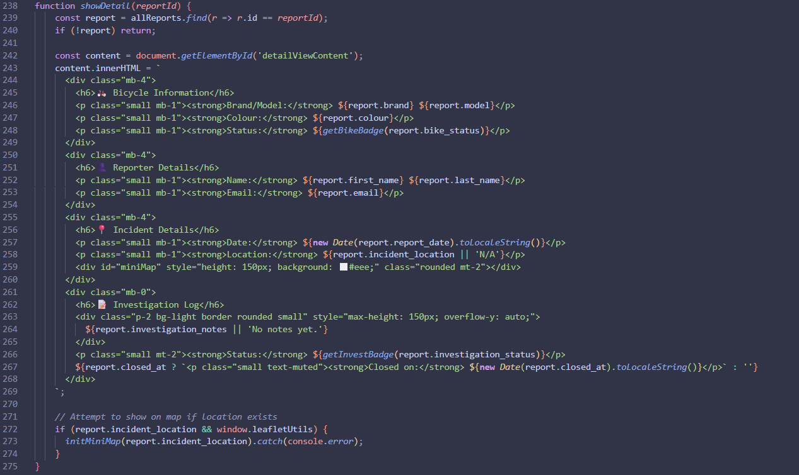
Figure 9

The Admin user page is admin/admin.html. The page is accessible by Admin users only.
The features of this web page allow the Admin users to:
- enrol new Admin, Police and Public users, by creating login details (users name, password, location, email, and location).
- view each database and export the data on them.
- view a log of every action that has altered the database.
- access the public and police pages.
- modify user data for any user in the “user” table.
The function below is from api/users.php and will update the user details based on the role of the user who requested it. The function starts by saving the user details for after the record has been updated. Then importing the input details. Sanitizing the inputs to prevent SQL injection. Then the if statement is different depending on if the admin/admin.js or the public/public.js file are requesting an update. Then for both users the details will be updated but for the Admin user, there is extra error checking.
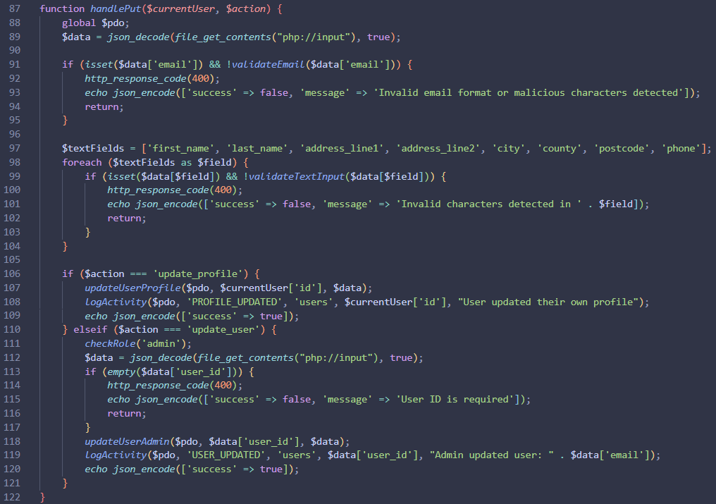
Figure 10

Testing

Documented evidence of the testing strategy used to test the website’s functionality throughout its development.
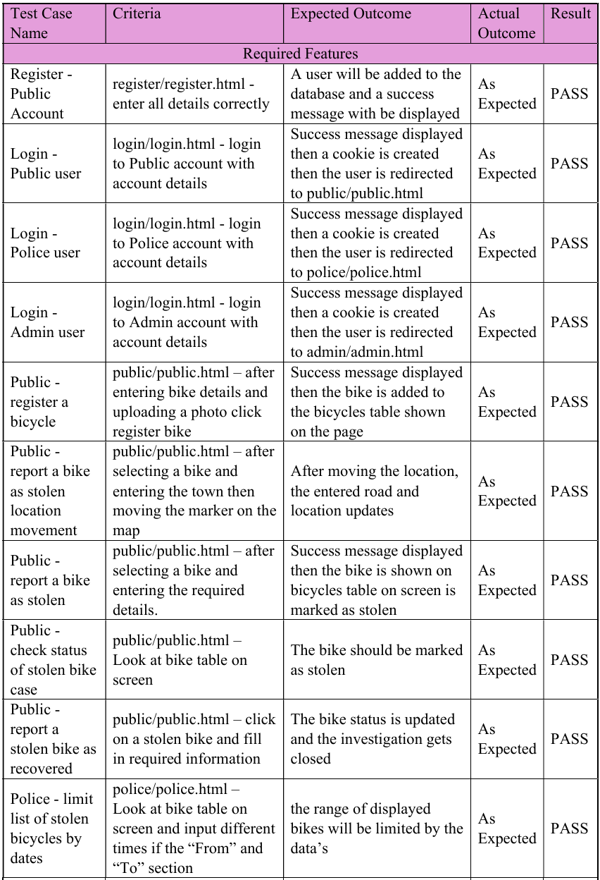
Figure 11
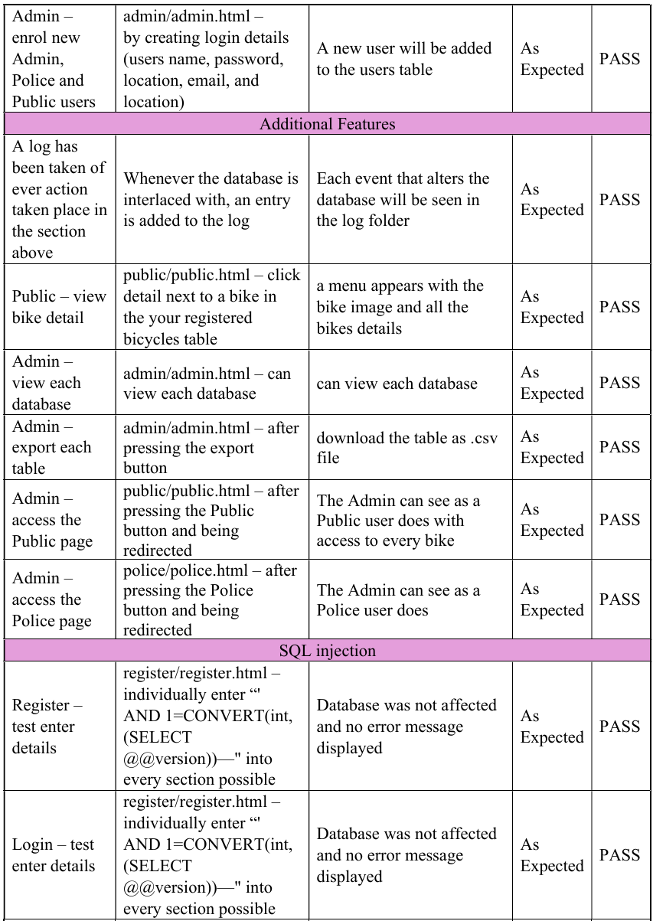
Figure 12
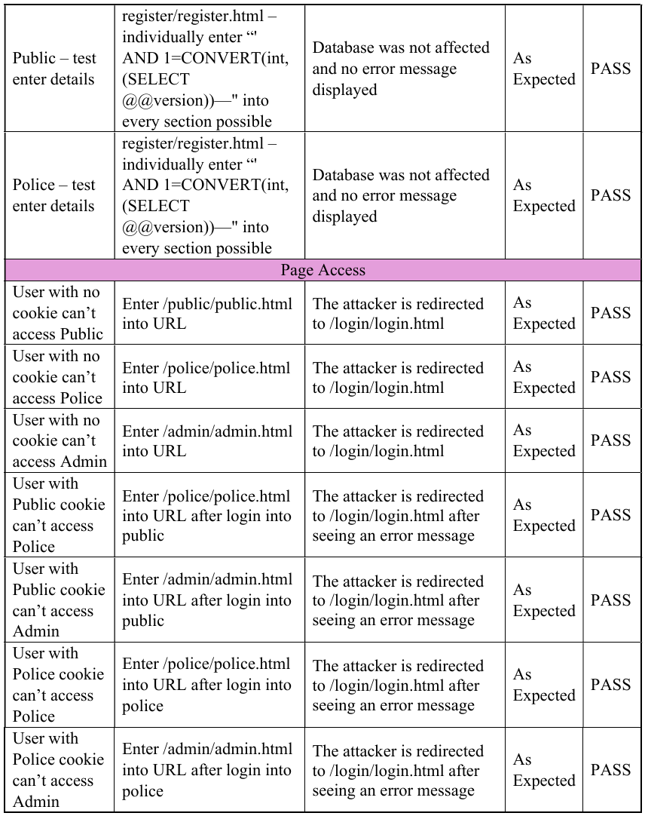
Figure 13

Security

Security has been considered throughout the prosses of building this website.
The security features are as follows:
Features i and ii follow the guidelines from Microsoft (2026).
- To prevent Buffer overrun attacks, every input has been limited to a set number of characters or a maximum number that can be input. For images the size has been limited to 5MB and limited to the formats JPG, PNG, and WebP.
- SQL injection prevention has been accomplished through sanitisation of inputs at every layer of the system. In the JavaScript code the format of the input is checked to prevent escape sequences. When the input is sent to the server, the PHP checks for the characters “;*_” and “–” since they can be used to escape sequences. The PHP also checks for words that are used within SQL statements to prevent them being used.
Enabled setting on the Plex server.
- The website uses https
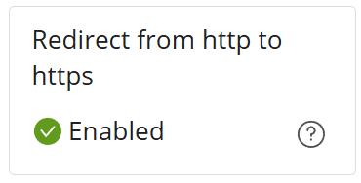
Figure 14
Insecure Direct Object Reference
- Insecure Direct Object Reference is an attack where the attacker changes the directory of the website they are on, to gain access to a higher privilege or further pages. To prevent this attack the database is only able to be accessed if the user has the correct cookie attached to the correct credentials.
- When a user logs into the system a session is started, a CSRF token is generated, and a HTTP cookie is generated. The session will end when the user logs out or the session expires after 1 hour.
Log table
- The Log table contains records of every alteration to the database with an identifying id for the type of action.
Admin users can view the log table but are not able to alter it.
Password following GCHQ and CPNI (2015) guidelines
- When a Public user is entering a password, to ensure the strength of the password there are requirements such as, uppercase and lowercase letters, numbers, and special symbols to make it harder to guess and at least 8 characters.
- There are many reasons that the password is hashed in the database. The first benefit is if the user table is stolen, the passwords can not be used to access each account without decoding the passwords. The second benefit is that it prevents SQL injection from the passwords input.

Project Plan

Outline of the Project
The project requirements are as follows:
There are three user types:
- Public
- Police
- Admin
Public can do the following using the website:
- Public must register personal and login details
- Public can login to the system
- Public can register one or more bikes. Table 1 below shows a list of bicycle attributes that can be used for registering bikes.
- Public can report a previously registered bicycle stolen
- Public can check progress / status of investigation of a reported bike
Police can do the following using the website:
- Police officers can login to the system
- Police officers can view a list of stolen bicycles reported in a specific week/ month/ year
- Police officers can update investigation status of reported bicycles
Admin Police can do the following using the website.
- Admin Police officers can login to the system
- An Admin Police can enrol other police officers, and create login details (user name and password) for them

Method used for project
In this paper an iterative design model is recommended for this system. As discussed in Fessenden (2024), an iterative design model repeats the same steps in the process multiple times to test for bugs and improves the user experience using feedback. Fessenden (2024) found “measured usability improvements (improved) by 38% per iteration.” This is also important to ensure that the website is secure at every level as user details and credentials must be protected. This paper also recommends 5-10 iterations for the most consistent results which minimises bugs seen by the users.

Reference List.

Every file within this program was written with the assistance of AI.
GCHQ and CPNI (2015) Password Guidance: Simplify Your Approach, Available at: https://assets.publishing.service.gov.uk/media/5a806bb9e5274a2e87db9b6a/Password_guidance_-_simplifying_your_approach.pdf
Microsoft (2026) SQL injection, Available At: https://learn.microsoft.com/en-us/sql/relational-databases/security/sql-injection?view=sql-server-ver17
MIT (2026) Build fast, responsive sites with Bootstrap, Available At: https://getbootstrap.com/
Nominatim developer community (2026) Nominatim Manual, Available At: https://nominatim.org/release-docs/develop/api/Overview/
Fessenden T (2024) 3 Design Processes for High Usability: Iterative Design, Parallel Design, and Competitive Testing, Available at: https://www.nngroup.com/articles/parallel-and-iterative-design/

Appendix 1: Screenshot of All Implemented Web Pages

Accessible to everyone
index.html
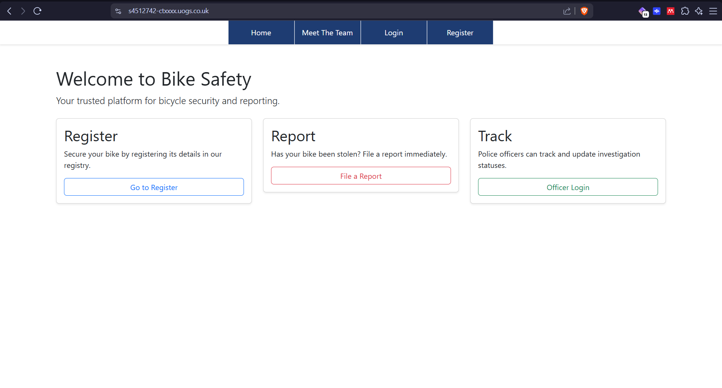
Figure 15
home/meet-the-team.html
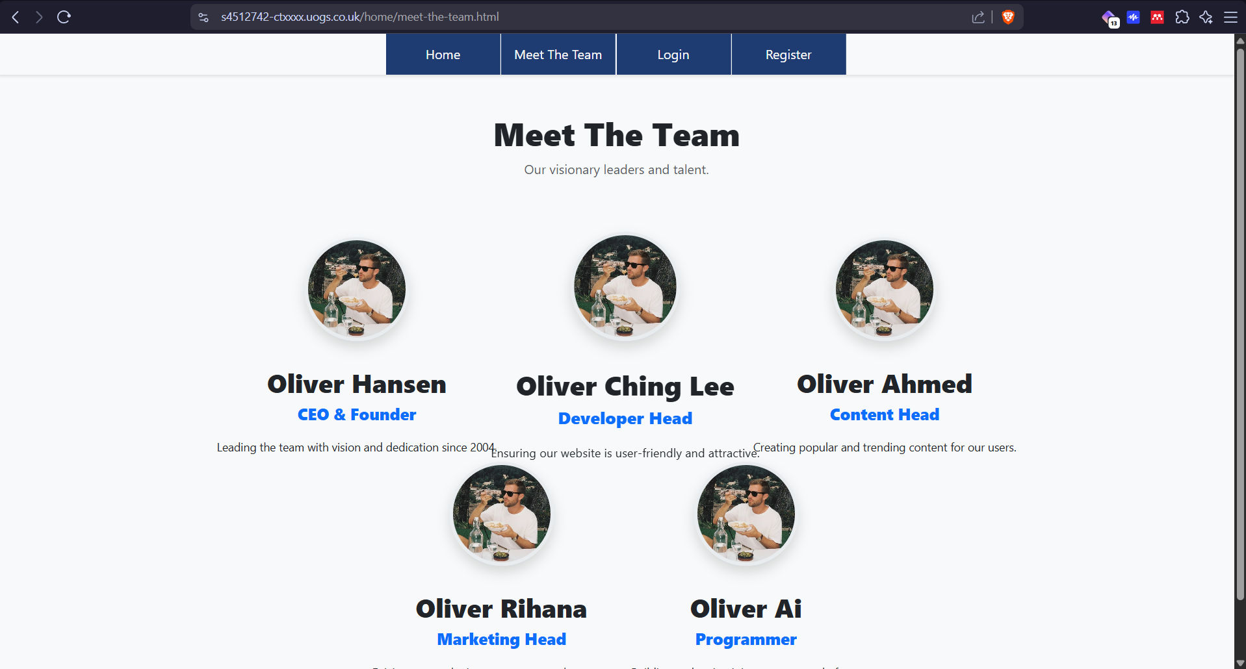
Figure 16
login/login.html
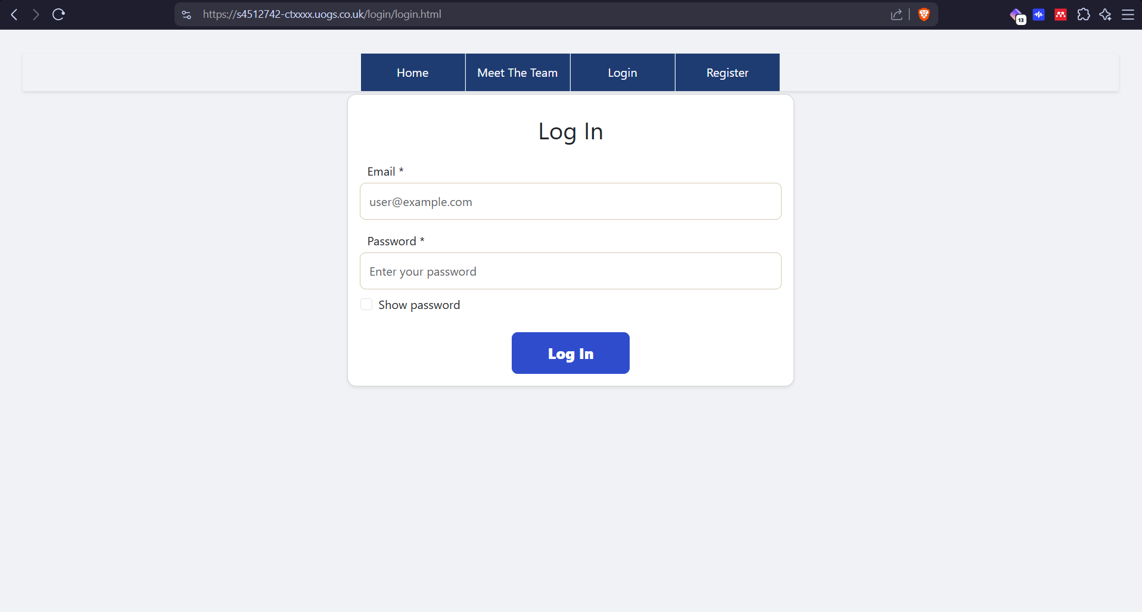
Figure 17
register/register.html
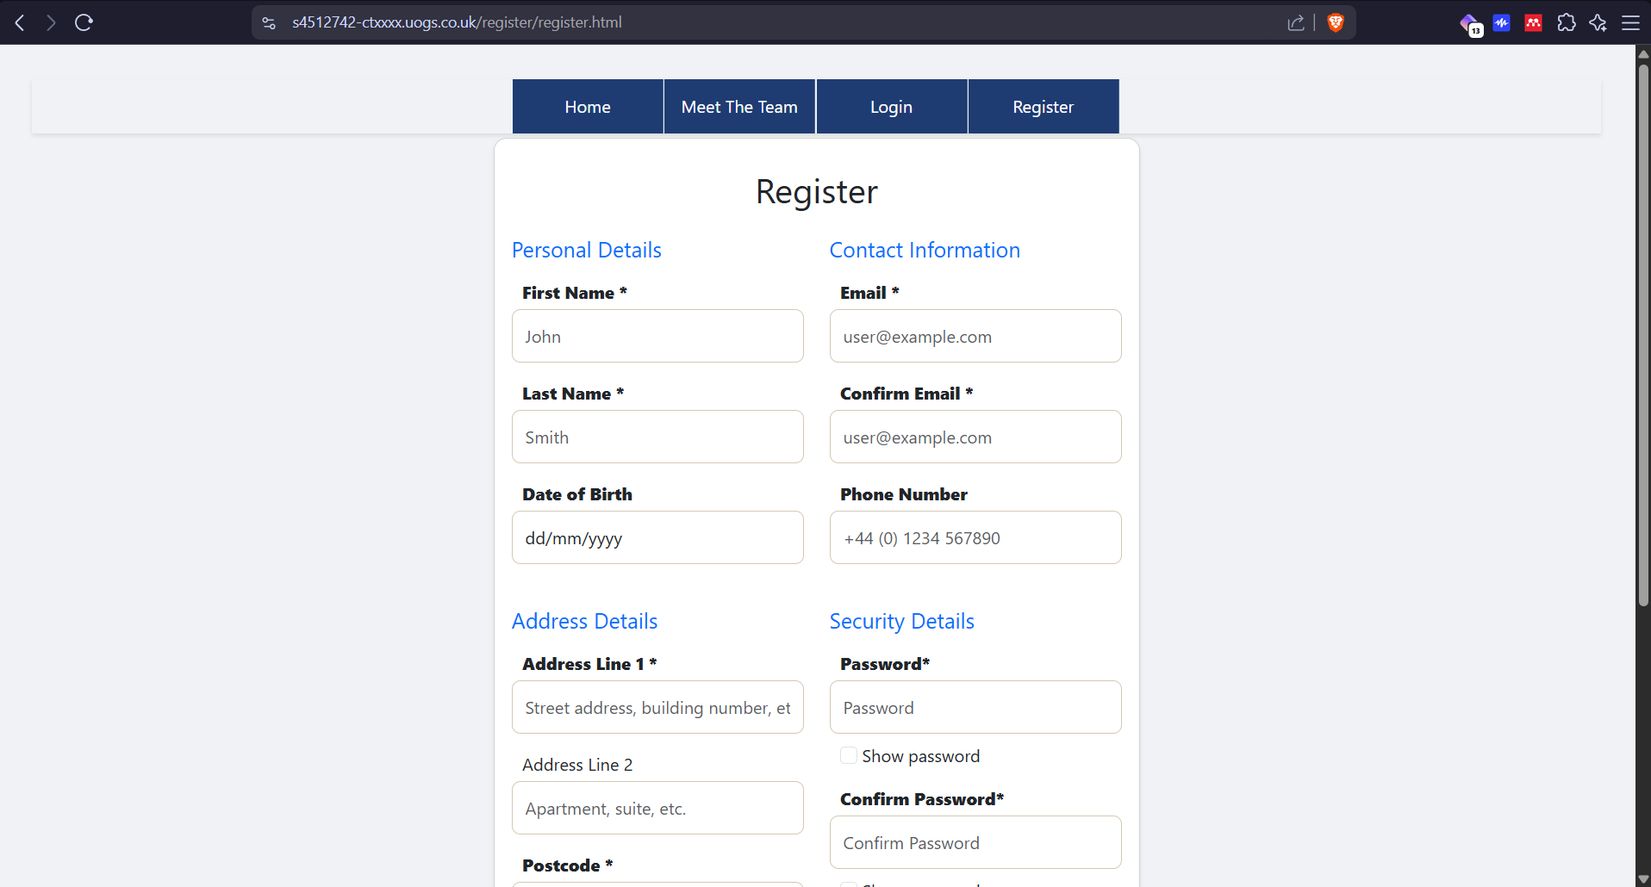
Figure 18

Accessible to Public and Admin user
public/public.html
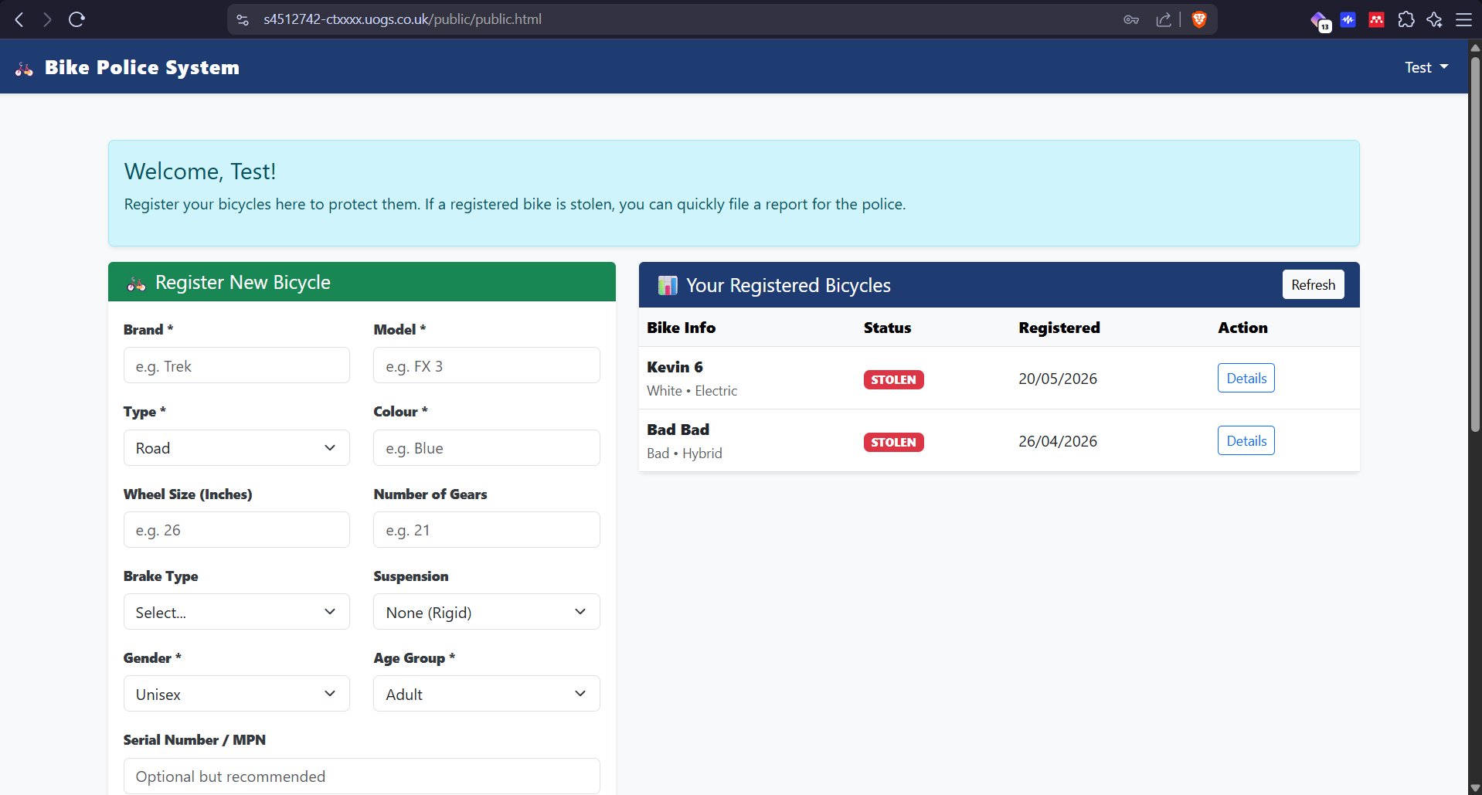
Figure 19
Bottom half of the page
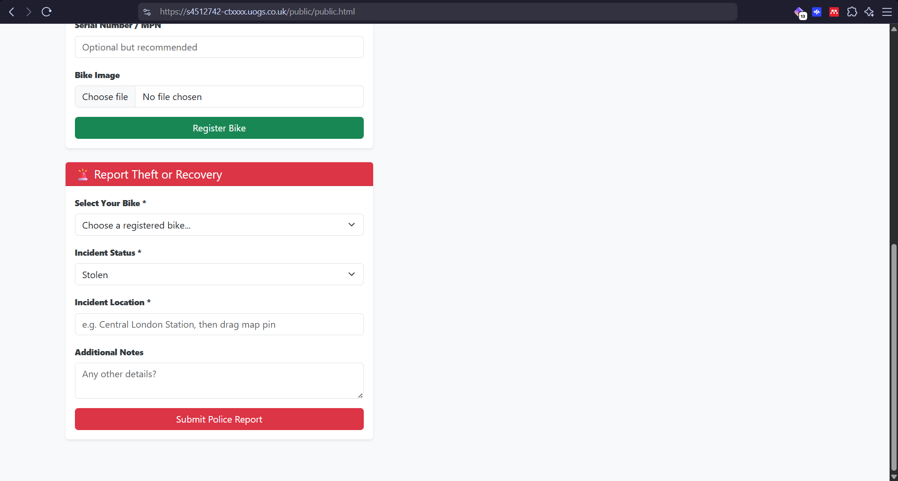
Figure 20
Bike details button
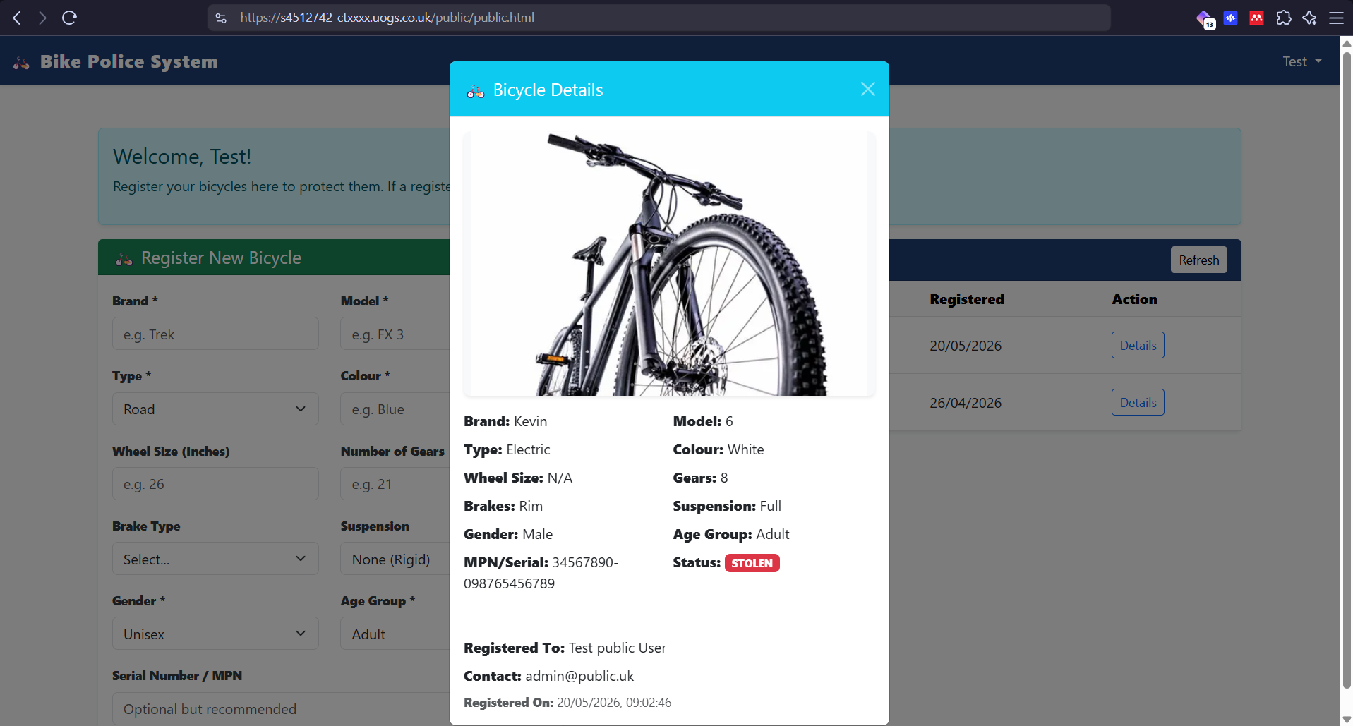
Figure 21
Profile button
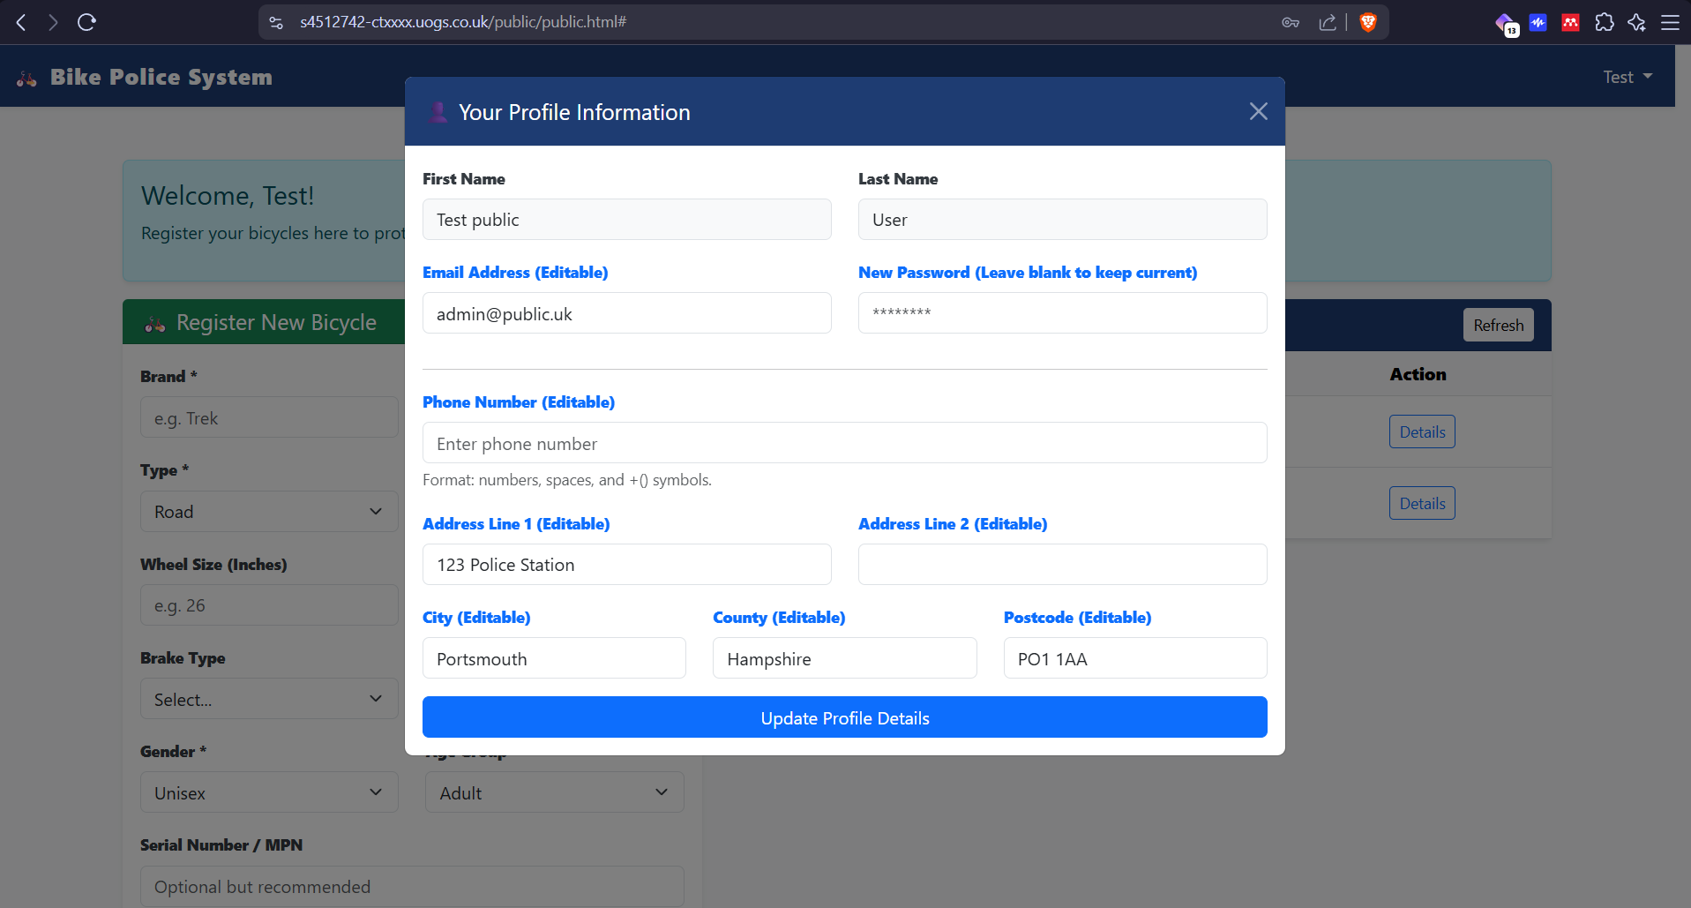
Figure 22

Accessible to Police and Admin user
police/police.html
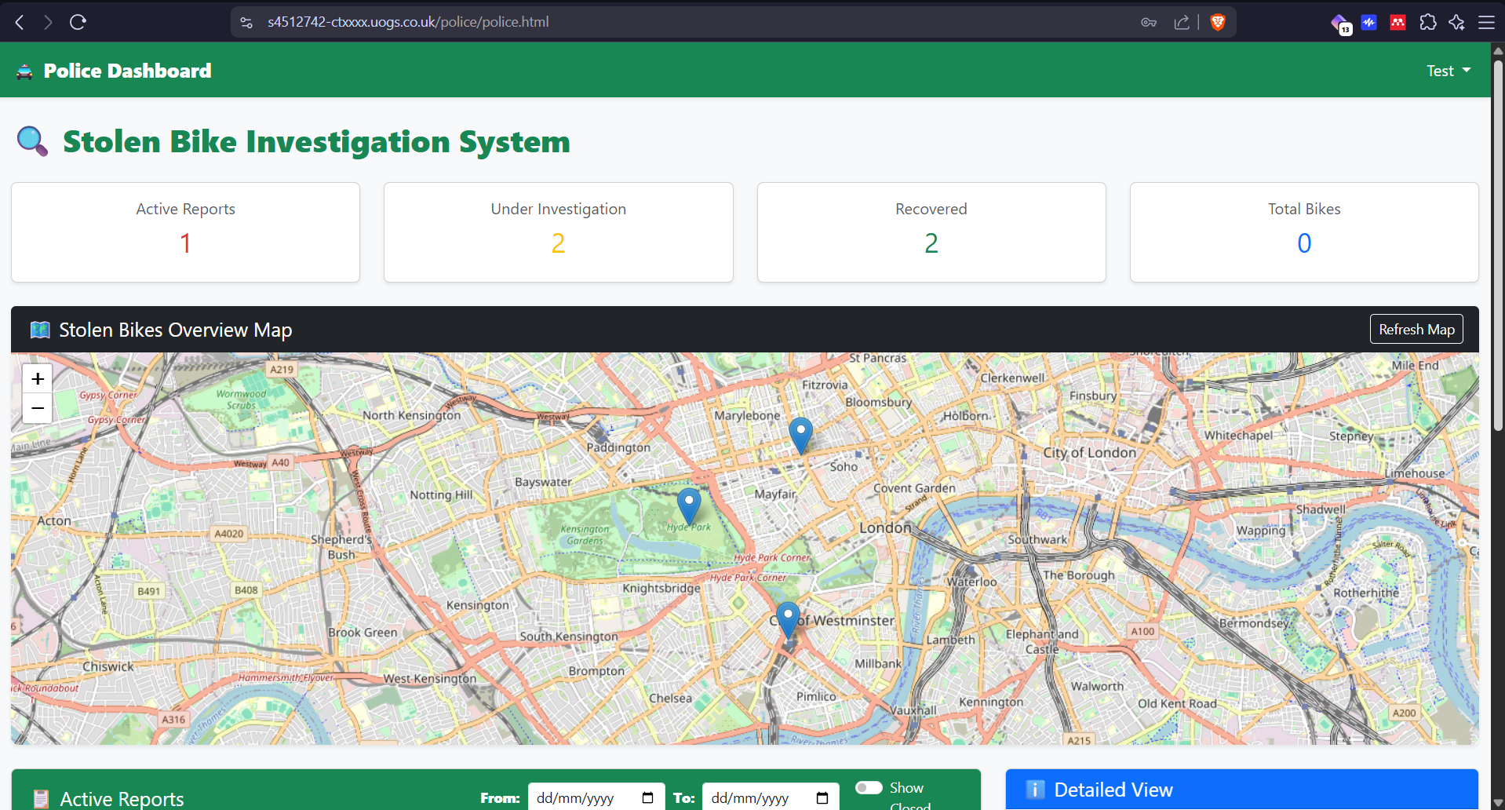
Figure 23
Scroll down the page
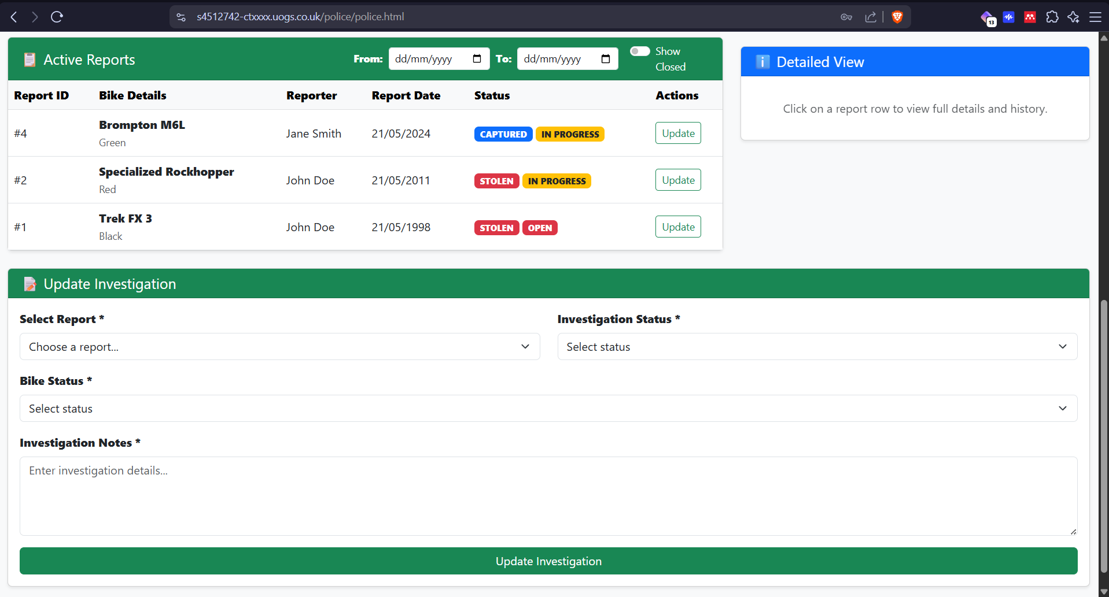
Figure 24
Click on bike record
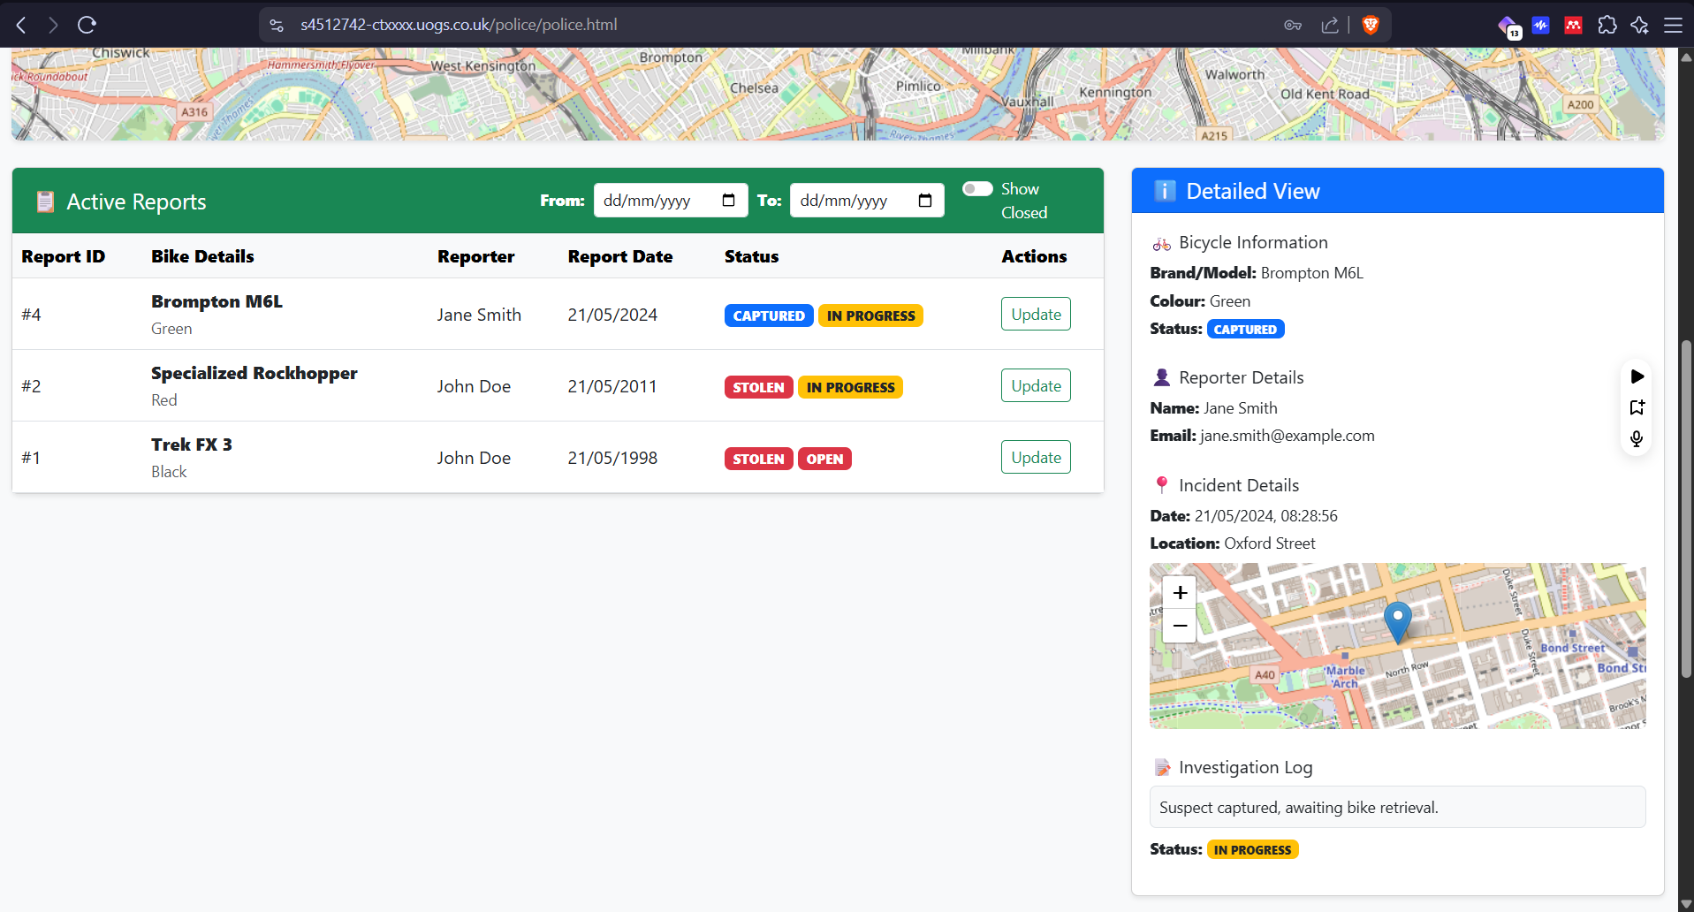
Figure 25
Profile button
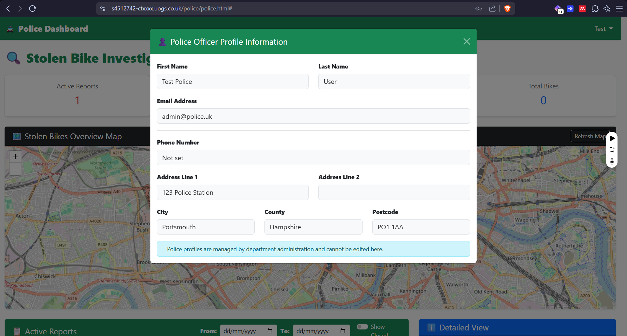
Figure 26

Accessible to Admin user
admin/admin.html
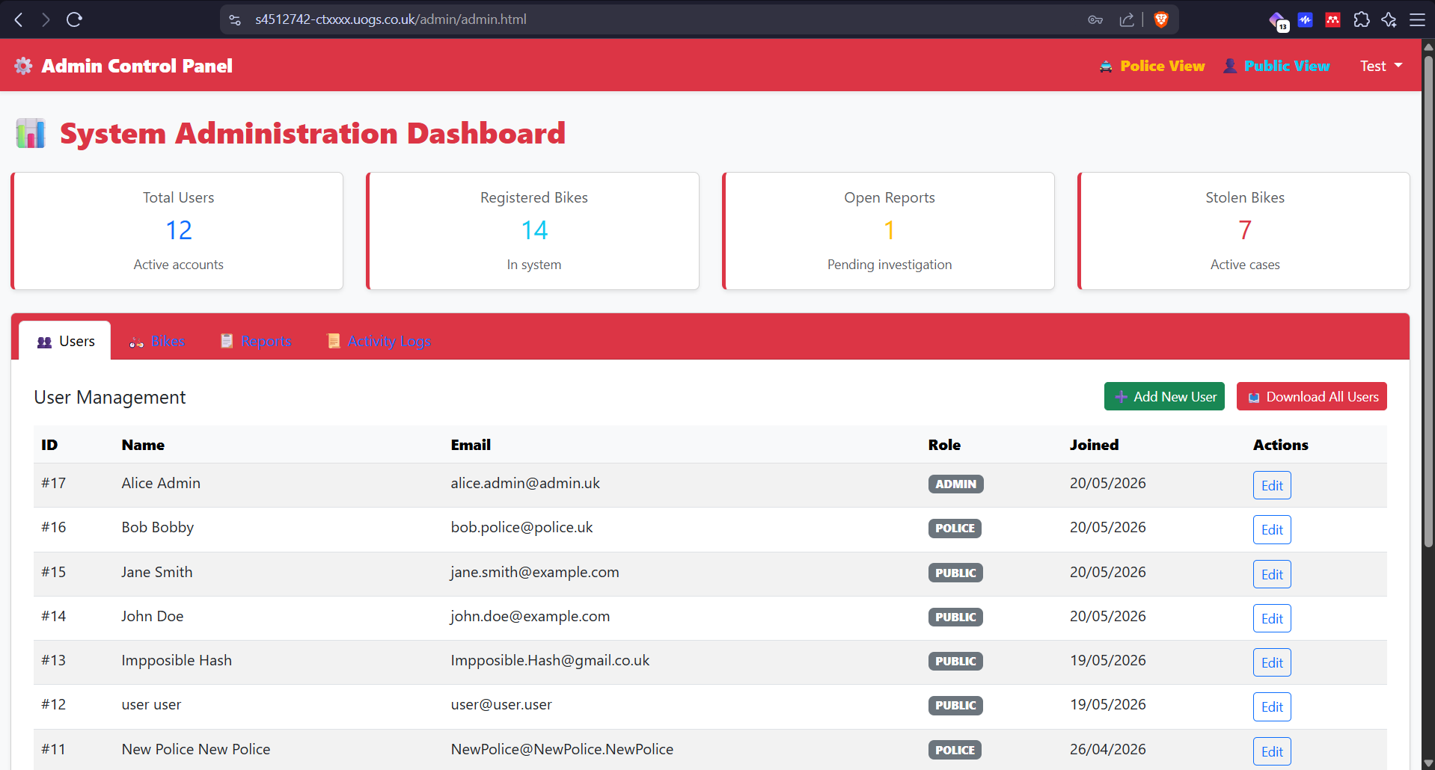
Figure 27
Click Add New User
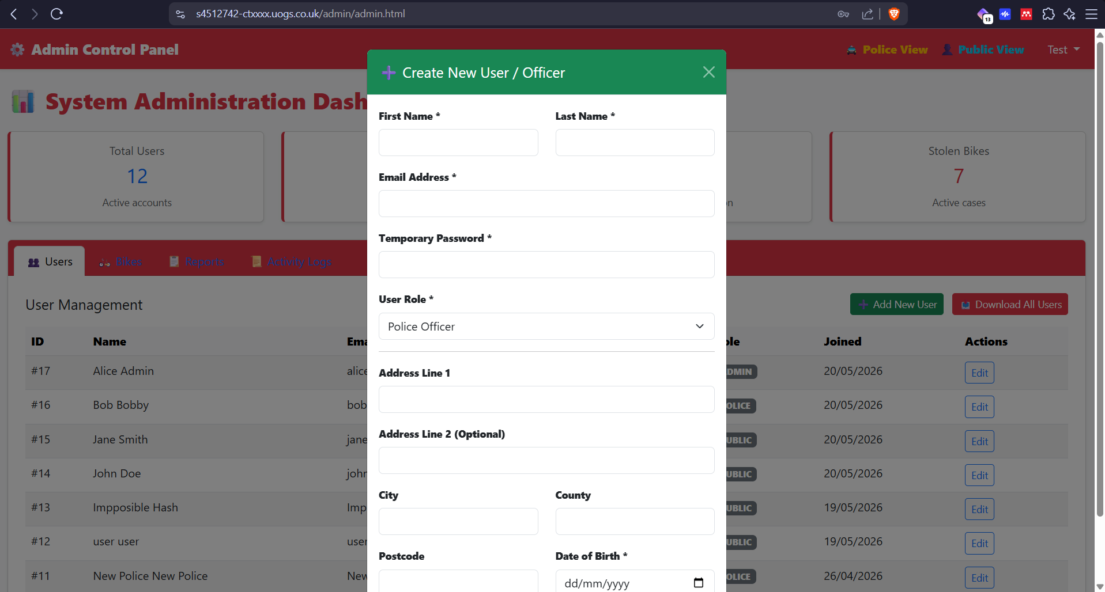
Figure 28
Select Bikes
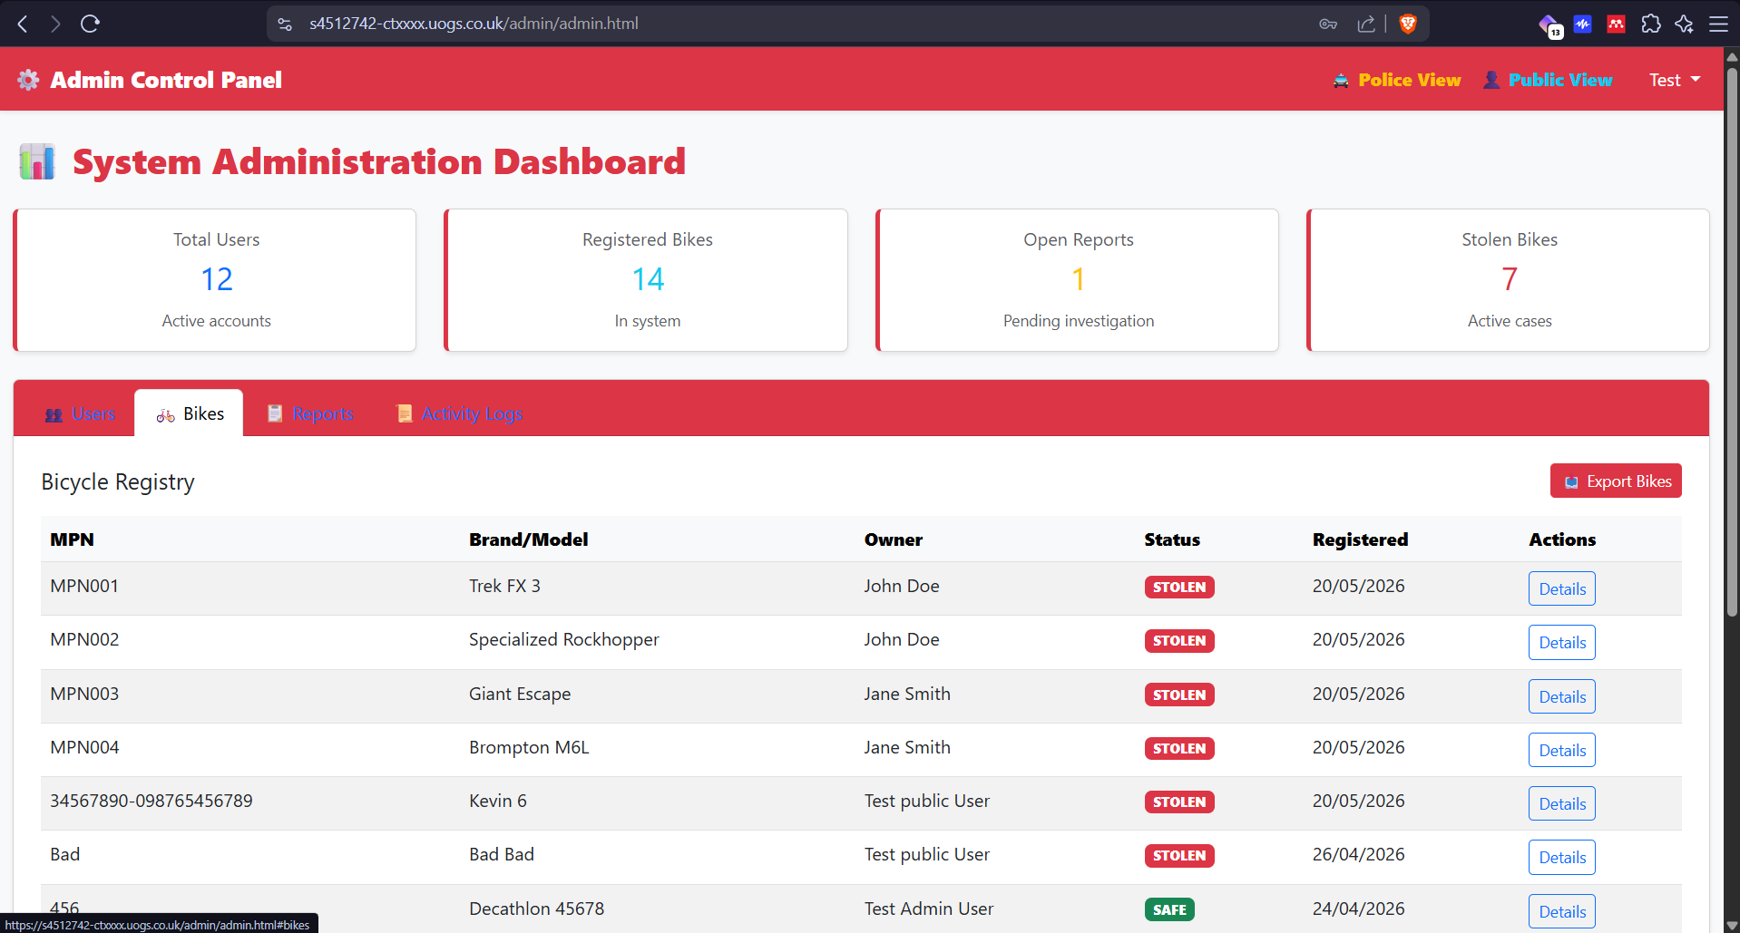
Figure 29
Select Reports
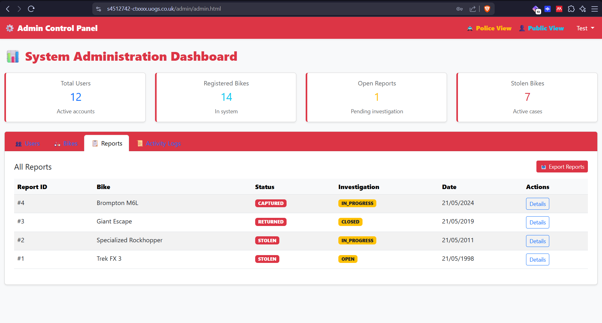
Figure 30
Select Activity Logs
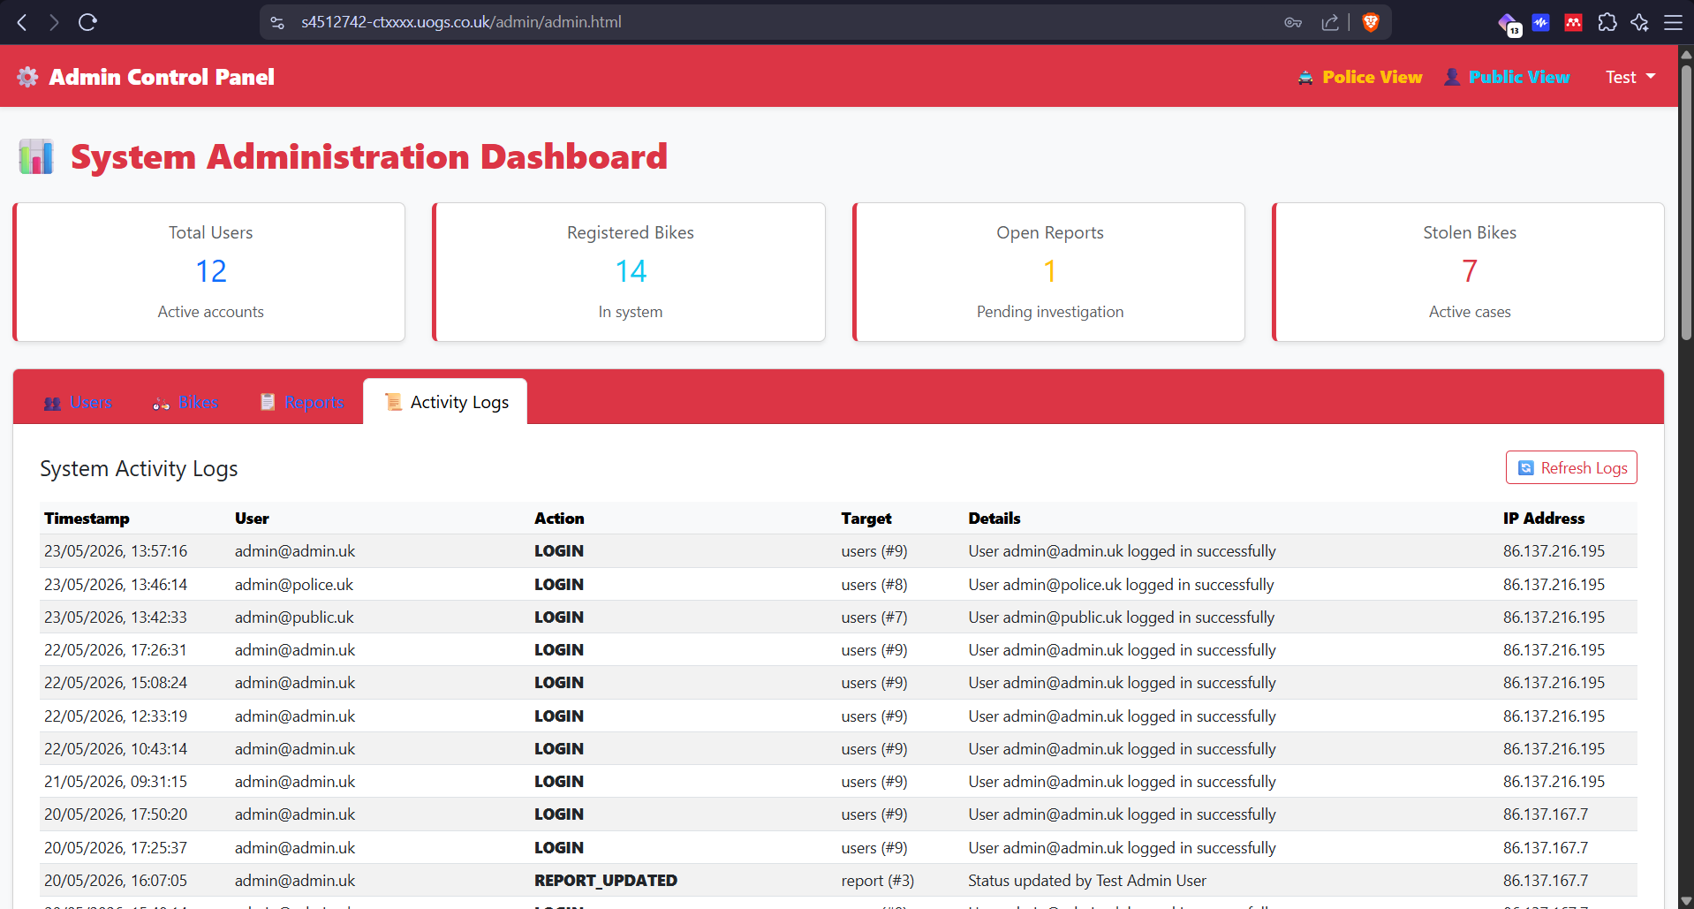
Figure 31

Appendix 2: All Source code
(HTML, CSS, Javascript, PHP, MySQL database build code).
The full program is attached as a .zip file

